Digital Twin-Enabled Explainable Structural Health Monitoring Framework for Bridge Infrastructure

Dr. V. Devisurya¹, Dhivyashri K K², Hemavarshini V³

¹ Assistant Professor (SLG), Department of Information Technology, Kongu Engineering College, Perundurai, Tamil Nadu, India; devisurya.it@kongu.edu

²,³ Department of Information Technology, Kongu Engineering College, Perundurai, Tamil Nadu, India;dhivyashrikk.23it@kongu.edu; hemavarshiniv.23it@kongu.edu

Abstract
Bridges require continuous and interpretable condition monitoring, yet change detection, condition classification and model explanation are rarely combined and evaluated together on a common benchmark. This paper presents a digital-twin monitoring prototype that integrates Bayesian online change point detection (BOCPD), an XGBoost condition classifier, SHAP attribution and a weighted risk score in one configurable pipeline, and reports its exact behaviour on the Z24 bridge benchmark. Seventeen ambient-vibration records (one per Z24 scenario, 16 distinct recording identifiers) were divided into 64 544 overlapping windows, each described by 24 time- and frequency-domain features. BOCPD applied to 496 sensor–recording RMS sequences produced no crossing of the 0.80 decision threshold; the maximum change probability was 0.785 and 144 windows (0.22%) exceeded 0.5. Under a recording-grouped holdout (47 417 training and 17 127 test windows), the classifier reached an accuracy of 49.82% (95% CI 49.07–50.56%), a ROC-AUC of 0.487 (95% CI 0.479–0.496) and a REFERENCE recall of 0.51%, which is no better than chance. SHAP analysis of 2000 held-out windows ranked dominant frequency, window mean and frequency centroid as the most influential features. The prototype runs end-to-end and exposes every intermediate evidence stream to the engineer, while the results show that amplitude-normalised short-window statistics do not separate the Z24 reference and altered conditions across recordings.
Keywords: Bayesian online change point detection; digital twin; explainable artificial intelligence; SHAP; structural health monitoring; XGBoost; Z24 bridge.
GIT LINK: https://github.com/Dhivyashri-6/Digital_twin_bridge.git

1. INTRODUCTION
Road bridges are among the most critical assets of transport networks, and a growing share of them is operating beyond its original design life. Periodic visual inspection remains the main source of condition information, but it is labour-intensive, partly subjective and blind to changes that occur between visits. Structural health monitoring (SHM) addresses this gap by recording the dynamic response of a structure continuously and converting it into quantitative evidence about its state [12], [13].
The premise of vibration-based SHM is that changes in stiffness, mass or boundary conditions alter the measured dynamic response, so that damage can be inferred from changes in vibration characteristics [14], [15]. Over the last decade, machine-learning and deep-learning methods have been applied extensively to this problem [16]–[19]. In practice, however, the analytical stages that an engineer needs – detecting when the behaviour changed, estimating what condition a measurement resembles and understanding why a model reached its output – are usually developed and evaluated separately.
Digital twins offer a way to bring these stages together. A digital twin couples a physical asset with a virtual representation that is updated from measured data and supports decision making throughout operation and maintenance [5], [10], [11]. Recent reviews and frameworks for civil and bridge infrastructure [6]–[9] emphasise the integration of sensing, analytics and

visualisation, but also note that many implementations stop at data management. Lu et al. [4] showed that Bayesian change point detection can serve as the anomaly-detection engine of a digital twin for built assets, using pump data from a building. Their framework did not include a supervised classification stage or a model-explanation layer, and it was not applied to bridge vibration data.
Explainability matters in SHM because an alarm without supporting evidence is difficult to audit or act upon. SHAP [2] attributes a model output to its input features in a consistent, additive way and is available in exact form for tree ensembles such as XGBoost [3]. BOCPD [1] complements supervised models because it needs no labelled damage data, which is rarely available for bridges in service.
This paper describes a digital-twin monitoring prototype for bridge SHM that chains BOCPD, XGBoost, SHAP and a weighted risk score, and reports the exact results obtained when the implemented pipeline is run on the Z24 bridge benchmark [20], [21]. All numerical values in Section 5 are taken directly from the pipeline outputs or recomputed from the saved model and data. Section 2 reviews related work, Section 3 describes the benchmark and the data used, Section 4 presents the method, Section 5 reports the experimental results, Section 6 discusses the results and Section 7 concludes the paper.
2. RELATED WORK
2.1. Vibration-based SHM and machine learning
Farrar and Worden [12] framed SHM as a statistical pattern-recognition problem comprising operational evaluation, data acquisition, feature extraction and statistical model development. Worden and Dulieu-Barton [13] reviewed intelligent fault detection and highlighted feature selection and data fusion as central issues. The early literature reviews of Doebling et al. [14] and Carden and Fanning [15] catalogued damage-identification methods based on modal parameters, frequency response functions and time-domain signal statistics. More recent surveys document the shift towards data-driven approaches: Avci et al. [16] traced the move from traditional methods to machine-learning and deep-learning techniques in civil structures, Hou and Xia [17] reviewed vibration-based damage identification developed between 2010 and 2019, Malekloo et al. [18] discussed machine learning with emerging sensing technologies and high-dimensional data, and Cha et al. [19] summarised deep-learning-based SHM. A recurring observation in these reviews is that environmental and operational variability can mask or mimic damage-induced changes, and that reliable validation requires data from independent measurement campaigns.
2.2. Digital twins for civil and bridge infrastructure
Davila Delgado and Oyedele [11] examined how conceptual and process models of digital twins from manufacturing can be transferred to the built environment, and AlBalkhy et al. [10] reviewed definitions, applications and open challenges of digital twins in construction. For civil structures, Torzoni et al. [5] proposed a digital-twin framework that combines physics-based reduced-order models with deep learning for structural health monitoring and decision making. Sun et al. [6] reviewed the development of digital twins for SHM of civil infrastructure, covering data acquisition, modelling and health assessment. Bridge-specific work includes the review of Franciosi et al. [7] on digital twins for streamlined bridge maintenance and sustainability, the unified bridge digital-twin framework of Hoskere et al. [8], and the demonstration by Nasim et al. [9] of a digital-twin framework that links real-time bridge monitoring data with anomaly detection.
2.3. Change detection and explainable models
BOCPD, introduced by Adams and MacKay [1], maintains a posterior distribution over the run length – the number of observations since the last change – and updates it recursively as data arrive. Lu et al. [4] embedded Bayesian change point detection in a digital-twin-enabled anomaly-detection process for asset monitoring during operation and maintenance. XGBoost [3] is a regularised gradient-boosted tree ensemble that performs well on tabular feature data, and SHAP [2] provides additive, game-theoretic feature attributions whose exact tree variant makes it a natural companion for XGBoost. For bridges, the Z24 benchmark [20] and its one-year monitoring campaign [21] remain standard references, notably because they show how temperature-driven changes can be as large as damage-induced changes.
3. PRELIMINARY STAGE
3.1. Z24 bridge benchmark
The Z24 bridge was a post-tensioned concrete box-girder bridge in Switzerland that crossed the A1 motorway between Bern and Zurich. Before its demolition at the end of 1998 it was monitored for about one year [21] and then subjected to progressive damage tests (PDT) comprising 17 scenarios [20]. Scenarios 01, 02 and 08 are reference measurements, and the remaining scenarios introduce controlled changes of increasing severity (Table 1). Ambient vibration was recorded in several sensor setups per scenario [20].
Table 1
Progressive damage test scenarios of the Z24 bridge [20] and labels used in this study
No. | Scenario | Label
01 | First reference measurement | REF
02 | Second reference (lowering system installed) | REF
03–06 | Lowering of pier by 20, 40, 80 and 95 mm | ALT
07 | Lifting of pier, tilt of foundation | ALT
08 | Third reference measurement | REF
09–10 | Spalling of concrete (12 and 24 m²) | ALT
11 | Landslide at abutment | ALT
12 | Failure of concrete hinge | ALT
13–14 | Failure of anchor heads (two stages) | ALT
15–17 | Rupture of tendons (three stages) | ALT

3.2. Data used in this study
The pipeline processed one file per scenario from the PDT folders: the first-setup MATLAB file (setup 01, 33 acceleration channels) for 15 scenarios and a single-channel ASCII record (100V.aaa) for scenarios 06 and 17. Because both ASCII files share the file stem 100V, they received the same recording identifier, so the 17 files correspond to 16 recording identifiers and 496 sensor–recording sequences. The ASCII header declares a sample interval of 0.01 s (100 Hz). The MATLAB files carry no sampling-rate field and no rate was configured, so the pipeline used its 1 Hz fallback for them; consequently the spectral features of 99.6% of the windows are expressed in cycles per sample rather than in hertz. Table 2 summarises the data. The long-term monitoring (EMS) archives were not processed.
Table 2
Data processed by the pipeline
Item | Value
Files processed | 17 (15 .mat, 2 .aaa)
Recording identifiers | 16
Channels per .mat file | 33
Samples per channel | 65 000–65 536
Sensor–recording sequences | 496
Windows per channel | 129–130
Total windows | 64 544
Windows with known rate (100 Hz) | 260 (0.4%)
REFERENCE windows (3 recordings) | 12 870
ALTERED_CONDITION windows (13 recordings) | 51 674

3.3. Label assignment
Labels are assigned by regular-expression rules applied to the source path and are recorded, with their match counts, in a label-mapping file. Scenarios 01, 02 and 08 are mapped to REFERENCE (12 870 windows) and scenarios 03–07 and 09–17 to ALTERED_CONDITION (51 674 windows). These labels describe the test protocol; they are not independent measurements of structural damage.
4. METHOD
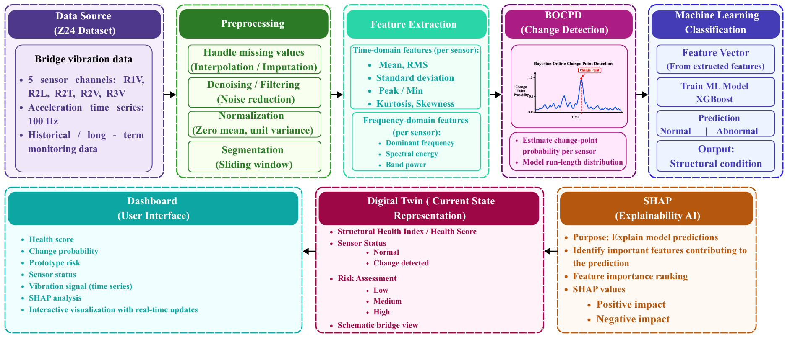
The implemented workflow is shown in Fig. 1. Every stage writes its output to a file, so that the digital-twin dashboard and any later analysis read exactly the same evidence.
Fig. 1. Processing pipeline of the digital-twin SHM prototype
4.1. Preprocessing and windowing
Each channel is validated (at least eight samples and at least one finite value); NaN and infinite samples are replaced by linear interpolation. The signal is linearly detrended and standardised to zero mean and unit variance over the whole record. A Butterworth band-pass filter (0.5–40 Hz, order 4) is implemented but was disabled. Windows last 10 s when the sampling rate is known and 1000 samples otherwise, with 50% overlap; each window keeps the scenario, setup, sensor, recording and source-file metadata of its parent record.
4.2. Feature extraction
Each window is described by 24 numerical features. Eleven are time-domain statistics: mean, standard deviation, variance, RMS, minimum, maximum, absolute peak, peak-to-peak value, crest factor, skewness and kurtosis. Definitions of the main features are given in Table 3. Five are spectral descriptors computed from Welch’s power spectral density (segment length 256): dominant frequency, spectral energy, frequency centroid, spectral bandwidth and PSD peak. Band energies are computed for four bands limited by the Nyquist frequency. Because the band limits depend on the sampling rate, the 1 Hz and 100 Hz windows produced two different sets of four band-energy columns, giving eight band-energy features in total; values absent for a window are filled with the training median.
Table 3
Definitions of selected features for a window x₁, …, x_{N} with PSD S(f_{k})
Feature | Definition
RMS | (1/N Σ x_{n}²)^{1/2}
Crest factor | max|x_{n}| / RMS
Skewness | E[(x − μ)³] / σ³
Kurtosis (excess) | E[(x − μ)⁴] / σ⁴ − 3
Dominant frequency | arg max_{k} S(f_{k})
Frequency centroid f_{c} | Σ f_{k}S(f_{k}) / Σ S(f_{k})
Spectral bandwidth | [Σ (f_{k} − f_{c})²S(f_{k}) / Σ S(f_{k})]^{1/2}
Spectral energy | Σ S(f_{k}) Δf

4.3. Bayesian online change point detection
BOCPD [1] is applied to the RMS sequence of each sensor–recording pair after centring by the median and scaling by the standard deviation of that sequence. Let γ_{t}(r) denote the joint probability of run length r and the observations up to window t, and π_{t}^{(r)} the Student-t posterior predictive density of x_{t} under the Normal–Gamma posterior of run r. With a constant hazard h, the growth and reset probabilities are
γ_{t}(r+1) = γ_{t−1}(r) π_{t}^{(r)} (1 − h), (1)
γ_{t}(0) = h π_{t}⁽⁰⁾ Σ_{r} γ_{t−1}(r), (2)
where π_{t}⁽⁰⁾ is evaluated with the prior parameters (μ₀ = 0, κ₀ = 1, α₀ = 1, β₀ = 1). The change probability reported for each window is
CP_{t} = γ_{t}(0) / Σ_{r} γ_{t}(r). (3)
The hazard is h = 0.01, the run-length distribution is truncated at 500, and a window is flagged when CP_{t} ≥ 0.80.
4.4. XGBoost condition classifier
The classifier is an XGBoost [3] ensemble with 300 trees, learning rate 0.05, maximum depth 6, row and column subsampling of 0.8, logistic loss and the histogram tree method, preceded by median imputation. To prevent overlapping windows of one record from appearing in both partitions, the data are split with GroupShuffleSplit using the recording identifier as group (25% of the groups for testing, random state 42).
4.5. SHAP attribution and sensor ranking
SHAP [2] decomposes the model output (in log-odds of the REFERENCE class) for window i into feature contributions φ_{ij}:
f(x_{i}) = φ₀ + Σ_{j} φ_{ij}, Φ_{j} = (1/N) Σ_{i} |φ_{ij}|, (4)
where Φ_{j} is the global importance of feature j. The pipeline computes exact path-dependent TreeSHAP values on the first 500 windows of the feature table and ranks sensors by the mean over windows of Σ_{j} |φ_{ij}|.
4.6. Risk score and digital-twin dashboard
A bounded risk score combines the BOCPD change probability B, the classifier probability of ALTERED_CONDITION M and the normalised sensor attribution A:
R = (w_{B}B + w_{M}M + w_{A}A) / (w_{B} + w_{M} + w_{A}), (5)
with w_{B} = 0.3, w_{M} = 0.5 and w_{A} = 0.2; R is mapped to LOW (< 0.35), MEDIUM (< 0.60), HIGH (< 0.80) or CRITICAL. The batch pipeline exports R with B only (M = A = 0), whereas the Streamlit dashboard combines all three terms for the latest window of each sensor. The dashboard replays the stored windows in order (0.5×–5× speed) and shows key indicators, a sensor status table, RMS and change-probability charts, class probabilities, the SHAP ranking, a detection log and a schematic bridge with evenly spaced sensor markers. A sensor is marked ANOMALY when CP ≥ threshold and M ≥ 0.5 or when R ≥ 0.60, and WARNING when one of the two conditions holds or R ≥ 0.35.
5. EXPERIMENTAL RESULTS
5.1. Experimental setup
The pipeline is implemented in Python 3.14 with NumPy, SciPy, Pandas, scikit-learn 1.9.0, XGBoost, SHAP, Plotly and Streamlit, and is configured by a single YAML file (Table 4). Additional statistics in this section (confidence intervals, per-recording results and held-out SHAP values) were recomputed from the saved model and feature table. The recomputed test predictions reproduce the stored confusion matrix exactly, and recomputed SHAP values on the stored 500-window subset reproduce the stored global importances to four decimal places. Window-level 95% confidence intervals use the Wilson method and, for ROC-AUC, the Hanley–McNeil standard error; because windows from one recording are correlated, these intervals understate the uncertainty at recording level.
Table 4
Configuration used in the experiments
Parameter | Value
Detrending / normalisation | linear / z-score per record
Band-pass filter | disabled
Window, overlap | 1000 samples (10 s), 50%
BOCPD feature, hazard h | RMS, 0.01
CP threshold, max. run length | 0.80, 500
XGBoost trees, depth, rate | 300, 6, 0.05
Subsampling (rows / columns) | 0.8 / 0.8
Split | GroupShuffleSplit, 25%, seed 42
Risk weights w_{B}, w_{M}, w_{A} | 0.3, 0.5, 0.2
Risk thresholds | 0.35, 0.60, 0.80

5.2. Change point detection
BOCPD was run on all 496 sensor–recording sequences (64 544 windows). No window reached the 0.80 threshold, so no change event was declared. The mean change probability was 0.0113 and the median 0.0065; 99.05% of the windows had CP < 0.1 and 144 windows (0.22%) had CP ≥ 0.5. These 144 windows belong to 121 of the 496 sequences (24.4%). The highest value, 0.7845, occurred in sensor 01_29 of recording 01setup01 (scenario 01) at window 103 (Fig. 2). In that sequence the two largest probabilities, 0.6483 at window 56 and 0.7845 at window 103, coincide with short RMS bursts of 1.88 and 2.49, which are typical of transient traffic excitation rather than a persistent change.
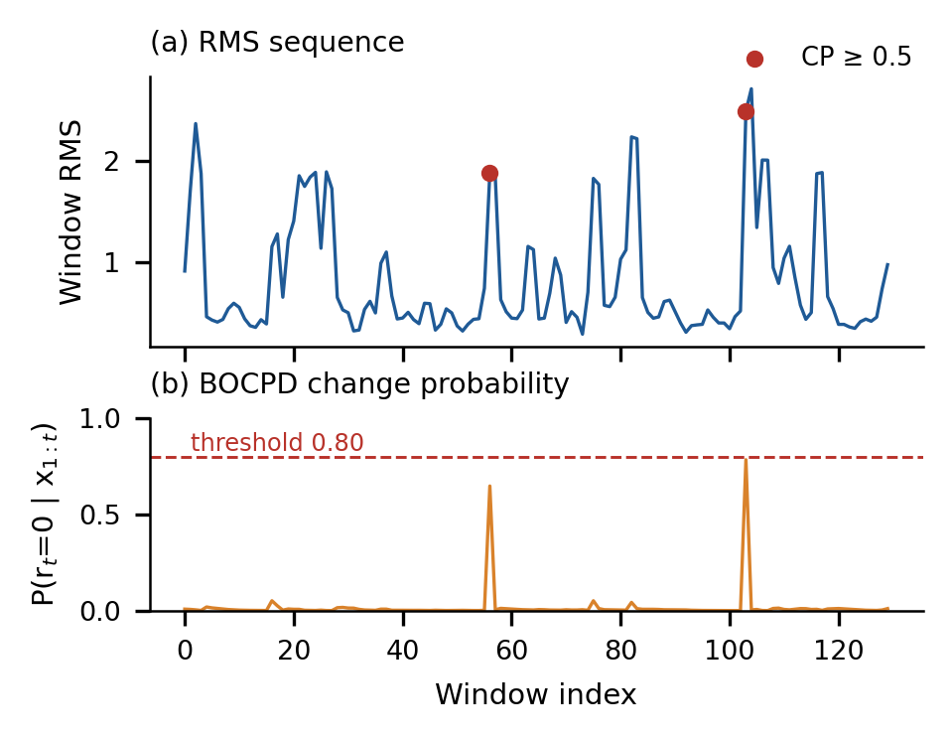
Fig. 2. BOCPD result for sensor 01_29, recording 01setup01, which contains the highest change probability of the data set. (a) Normalised window RMS; markers show windows with CP ≥ 0.5. (b) Change probability and decision threshold
Table 5 and Fig. 3 summarise the results per scenario. The largest maxima and counts occurred in reference scenario 01 (max 0.7845, 45 windows ≥ 0.5) and in altered scenarios 04 (0.7765, 21 windows) and 10 (0.7762, 17 windows), while altered scenarios 03, 12 and 15 had no window above 0.5. Reference and altered scenarios therefore show no systematic difference, which is consistent with the design of the detector: each sequence lies within one scenario, so BOCPD measures non-stationarity inside a recording and cannot, in this configuration, register a change from one scenario to the next.
Table 5
BOCPD results per Z24 scenario (REF = reference). *Scenario 06 includes the scenario 17 record that shares its identifier
Scen. | Label | Windows | Mean CP | Max CP | CP ≥ 0.5
01 | REF | 4290 | 0.0168 | 0.7845 | 45
02 | REF | 4290 | 0.0118 | 0.7052 | 15
03 | ALT | 4257 | 0.0093 | 0.3916 | 0
04 | ALT | 4290 | 0.0127 | 0.7765 | 21
05 | ALT | 4290 | 0.0109 | 0.7140 | 7
06* | ALT | 260 | 0.0149 | 0.6653 | 1
07 | ALT | 4257 | 0.0113 | 0.5743 | 1
08 | REF | 4290 | 0.0112 | 0.5735 | 6
09 | ALT | 4290 | 0.0120 | 0.7173 | 14
10 | ALT | 4290 | 0.0111 | 0.7762 | 17
11 | ALT | 4290 | 0.0129 | 0.6409 | 13
12 | ALT | 4290 | 0.0097 | 0.2301 | 0
13 | ALT | 4290 | 0.0104 | 0.5495 | 1
14 | ALT | 4290 | 0.0095 | 0.7542 | 1
15 | ALT | 4290 | 0.0094 | 0.3442 | 0
16 | ALT | 4290 | 0.0098 | 0.5751 | 2

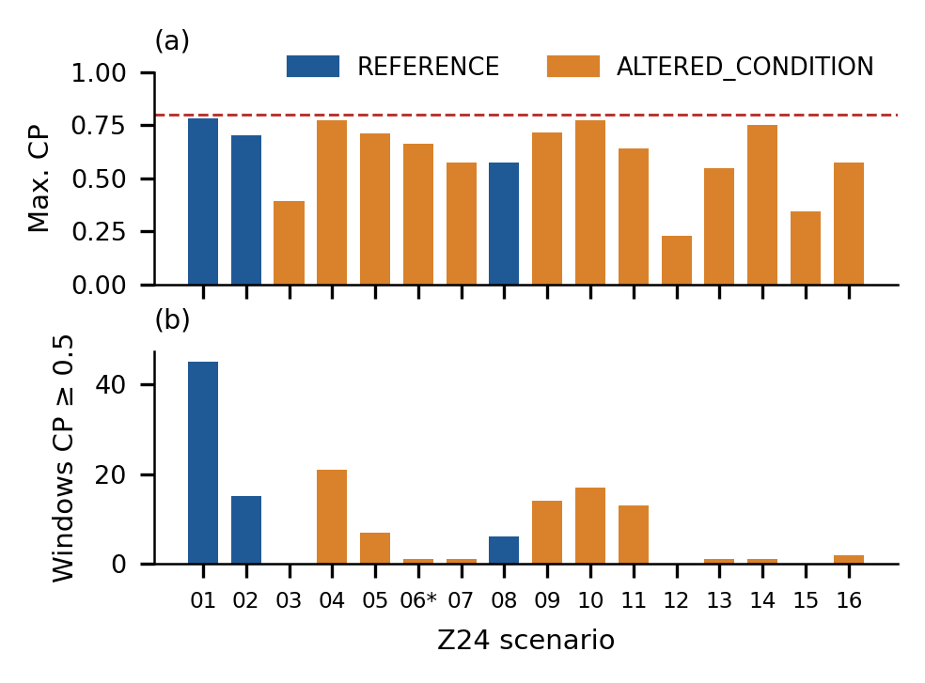
Fig. 3. Change probability per Z24 scenario. (a) Maximum CP with the 0.80 threshold. (b) Number of windows with CP ≥ 0.5. 06* includes the scenario 17 record
5.3. Condition classification
The grouped split placed recordings 01setup01, 02setup01 (REFERENCE), 07setup01 and 15setup01 (ALTERED_CONDITION) in the test set (17 127 windows: 8580 REFERENCE and 8547 ALTERED_CONDITION). The training set (47 417 windows) therefore contained a single REFERENCE recording, 08setup01 (4290 windows), against 43 127 ALTERED_CONDITION windows, and the model’s base score equals this training prevalence (4290/47 417 = 0.0905). Table 6 and Fig. 4a report the test results.
Table 6
XGBoost results on the grouped test set (n = 17127 windows) with window-level 95% confidence intervals
Metric | ALTERED_COND. | REFERENCE
Precision | 0.4986 [0.4911, 0.5061] | 0.4272 [0.3360, 0.5236]
Recall | 0.9931 [0.9911, 0.9946] | 0.0051 [0.0038, 0.0069]
F1-score | 0.6639 | 0.0101
Support | 8547 | 8580
Accuracy | 0.4982 [0.4907, 0.5056]
Balanced accuracy | 0.4991
Macro / weighted F1 | 0.3370 / 0.3364
MCC | −0.0115
ROC-AUC | 0.4873 [0.4787, 0.4960]

The classifier assigned 17 024 of the 17 127 test windows (99.4%) to ALTERED_CONDITION. Only 44 of the 8580 REFERENCE windows were recognised, and the ROC-AUC and Matthews correlation coefficient are at chance level. Table 7 and Fig. 4b show that this behaviour is the same for all four test recordings: the median predicted probability of REFERENCE lies between 0.047 and 0.093 for both reference and altered recordings, i.e. close to the training prevalence, so the model outputs do not depend on the true condition.
Table 7
Results per test recording (P = predicted probability of REFERENCE)
Recording | Label | Windows | Accuracy | Mean P | Median P
01setup01 | REF | 4290 | 0.0044 | 0.1106 | 0.0928
02setup01 | REF | 4290 | 0.0058 | 0.0722 | 0.0472
07setup01 | ALT | 4257 | 0.9880 | 0.0995 | 0.0797
15setup01 | ALT | 4290 | 0.9981 | 0.0814 | 0.0661

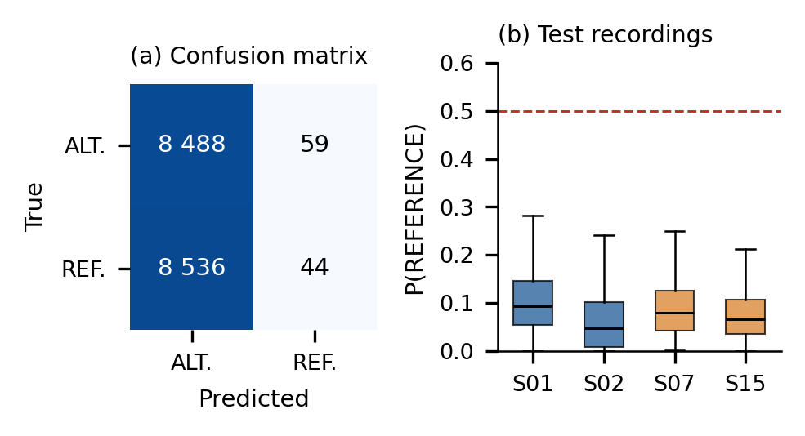
Fig. 4. Classification results. (a) Confusion matrix on the grouped test set. (b) Distribution of the predicted probability of REFERENCE for each test recording (S01, S02: REFERENCE; S07, S15: ALTERED_CONDITION); the dashed line marks 0.5
5.4. Feature separability
To examine why the classes were not separated, Table 8 compares the two classes over all 64 544 windows for ten features, using Cohen’s d and the probability that a REFERENCE window exceeds an ALTERED_CONDITION window (AUC). All effect sizes satisfy |d| ≤ 0.123. The per-record z-score normalisation fixes the variance of every record, so RMS, standard deviation and mean are almost identical in both classes (RMS 0.8808 versus 0.8951). The frequency descriptors show the largest single-feature AUC deviations (0.392 and 0.385), but they are expressed in cycles per sample for most windows and are mixed with the 260 windows analysed at 100 Hz.
Table 8
Class separability of individual features (all windows)
Feature | Mean REF | Mean ALT | d | AUC
RMS | 0.8808 | 0.8951 | −0.032 | 0.479
Std. deviation | 0.8459 | 0.8401 | 0.013 | 0.495
Mean | −0.0002 | −0.0002 | 0.000 | 0.504
Kurtosis | 2.8197 | 2.8543 | −0.007 | 0.462
Skewness | 0.0228 | 0.0163 | 0.024 | 0.504
Crest factor | 4.6166 | 4.5835 | 0.025 | 0.489
Dominant freq. | 0.1473 | 0.2939 | −0.103 | 0.392
Freq. centroid | 0.1813 | 0.3243 | −0.098 | 0.385
Spectral bandwidth | 0.0775 | 0.1059 | −0.069 | 0.570
PSD peak | 34.9833 | 27.3145 | 0.123 | 0.533

Fig. 7 shows the per-scenario distributions of window RMS and frequency centroid for the 64 284 windows of the 15 MATLAB records. The medians of the altered scenarios lie between 0.740 and 0.862 for RMS and between 0.203 and 0.236 cycles per sample for the frequency centroid, and they overlap with those of the reference scenarios. The largest deviation occurs within the REFERENCE class itself: scenario 02 has a median frequency centroid of 0.122, compared with 0.221 for scenario 01 and 0.219 for scenario 08. Differences between individual recordings are therefore larger than the differences between the two classes, which explains why a model trained on one reference recording (08) did not recognise the other two (01 and 02).
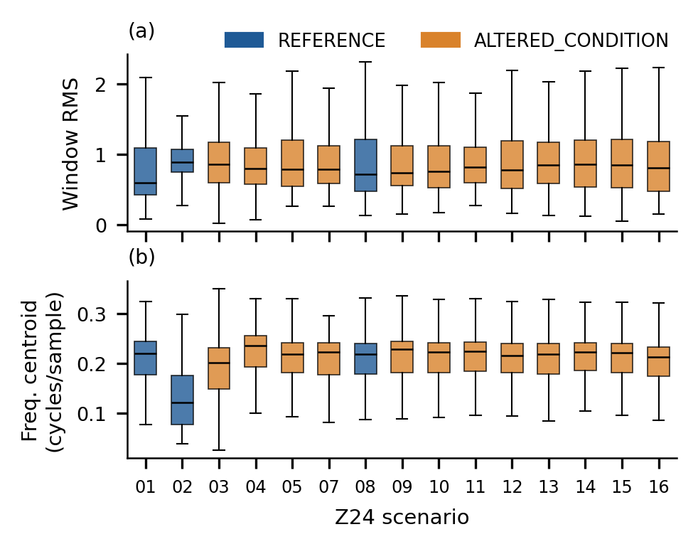
Fig. 7. Distribution of (a) window RMS and (b) frequency centroid per Z24 scenario for the 15 MATLAB records (whiskers: 1.5 IQR, outliers not shown)
5.5. SHAP attribution and sensor ranking
On the stored 500-window subset (sensors 01_0–01_3 of recording 01setup01, all training data), the highest mean |SHAP| values were RMS (0.2305), dominant frequency (0.2079) and mean (0.2071), followed by frequency centroid (0.1407) and skewness (0.1319). On 2000 held-out test windows (500 drawn at random from each test recording), the ranking changed to dominant frequency (0.4367), mean (0.2673), frequency centroid (0.2421), spectral bandwidth (0.1876) and RMS (0.1595) (Fig. 5). In both cases seven of the eight band-energy features received zero attribution, meaning that the trees never used them for splitting. The prominence of the window mean, which is close to zero after detrending and normalisation, indicates that the model relies partly on residual offsets rather than on known damage-sensitive quantities; together with the chance-level accuracy, the SHAP ranking should therefore be read as a description of the model, not of the structure.
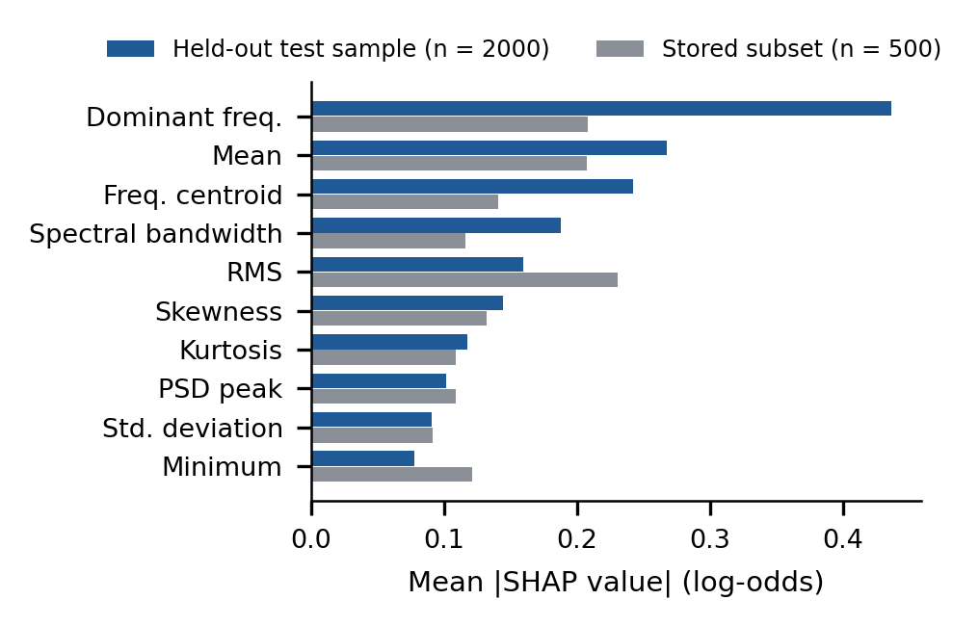
Fig. 5. Global SHAP importance of the ten highest-ranked features on 2000 held-out test windows, compared with the stored 500-window subset
The stored sensor ranking is derived from the same 500-window subset and therefore covers four sensors: 01_1 (1.9507), 01_2 (1.9200), 01_0 (1.8935) and 01_3 (1.8038). The spread of 7.5% between the first and last sensor shows that no sensor dominated the attribution.
5.6. Risk score and digital-twin state
Because the exported risk file uses only the BOCPD term, its maximum score is 0.3 × 0.7845 = 0.2354 and all 64 544 windows fall in the LOW band (mean score 0.0034). In the dashboard, the three terms are combined for the latest window of each sensor, and the key indicators, change-probability charts, SHAP ranking and schematic bridge are updated as the stored windows are replayed. The dashboard labels the replay as simulated real time and states that the health score is a monitoring indicator, not a safety certification.
To show what the digital twin reports, the dashboard logic was evaluated at the end of the replay (window 129) for scenario 01 (REFERENCE) and scenario 15 (ALTERED_CONDITION). Both views give the same overall state, POTENTIAL ANOMALY, with a prototype health score of 50% and 51%, 29 sensors in WARNING and 4 in ANOMALY (Fig. 6). The change probabilities of the latest windows were small (maximum 0.0468 and 0.0269), whereas the classifier assigned ALTERED_CONDITION probabilities of 0.812–0.997 and 0.776–0.999 to every sensor. The WARNING states are therefore produced by the classifier term, and the four ANOMALY sensors are exactly the sensors 01_0–01_3 that carry a stored SHAP importance. The fused indicator thus reproduces the bias of the classifier and cannot distinguish the reference scenario from the altered one.
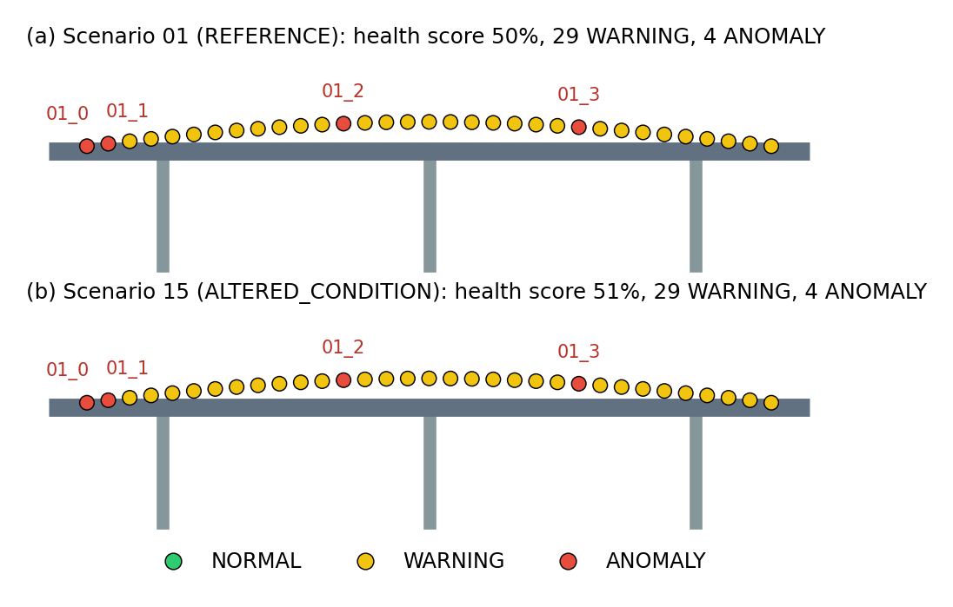
Fig. 6. Digital-twin schematic state at the end of replay (window 129), computed with the dashboard rules from the stored outputs. (a) Scenario 01. (b) Scenario 15. Sensor positions are schematic
5.7. Experimental summary
The complete pipeline executed on 64 544 windows from all 17 Z24 scenarios and produced change probabilities, class predictions, SHAP attributions, sensor rankings and risk scores that are traceable to stored files. BOCPD declared no change event at the 0.80 threshold (maximum 0.7845), and its elevated probabilities reflected transient bursts within recordings in both reference and altered scenarios. The recording-grouped classifier performed at chance level (accuracy 49.82%, ROC-AUC 0.487), with one REFERENCE recording available for training and near-zero class differences in the amplitude-normalised features. Because the fused risk score inherits this bias, the digital-twin view reported the same POTENTIAL ANOMALY state for a reference and an altered scenario. These results identify the data configuration – unresolved sampling rate for the MATLAB records, per-record normalisation, one setup per scenario and a single training reference recording – as the main factors that limit condition discrimination.
6. DISCUSSION
6.1. Interpretation of the results
The three analytical stages answered different questions and failed for different reasons. BOCPD behaved as designed: it reacted to short RMS bursts inside recordings, which are expected under ambient traffic excitation, and remained low elsewhere. It could not respond to the damage scenarios because every sequence was confined to a single scenario and because z-score normalisation per record removed differences in overall vibration level. For damage detection, the detector has to observe a sequence that spans the change, for example consecutive scenarios or the one-year monitoring record in which temperature effects must also be separated from damage [21].
The supervised stage shows why grouped evaluation matters. Overlapping windows produce a large number of samples (64 544), but the number of independent units is 16 recording identifiers, and only three of them belong to the REFERENCE class. With one reference recording in training, the classifier learned the training prevalence rather than a condition signature, and window-level metrics that would look favourable under a random split collapse to chance level under the grouped split. The feature analysis (Table 8, Fig. 7) shows that the variation between individual recordings, including the variation among the three reference recordings, exceeds the variation between classes for the amplitude-normalised features used here.
SHAP was nevertheless useful as a model audit. It revealed that the model relied on the window mean and on frequency descriptors that are not expressed in physical units, and that seven band-energy features were never used. These findings point directly to the preprocessing and sampling-rate issues identified above, which is the kind of transparency that the digital twin is intended to provide [4], [6]. The dashboard analysis (Fig. 6) also shows a risk of multi-stream fusion: a component with no discriminative power can dominate a weighted score. A practical safeguard is to include the classifier term only after it has passed a validation criterion such as a minimum grouped ROC-AUC.
6.2. Limitations
The labels describe the Z24 test protocol and not measured structural damage. Only the first sensor setup of each scenario was processed, the MATLAB records were analysed with a fallback sampling rate, and two records share one identifier. The reported confidence intervals are window-level and do not account for the correlation between windows of one recording. The stored SHAP values and sensor ranking cover a 500-window training subset and four sensors; the held-out SHAP analysis uses a random sample of 2000 test windows. The sensor layout in the dashboard is schematic, the replay is a simulation of streaming rather than a live connection, and the prototype contains no physics-based or finite-element model of the bridge.
7. CONCLUSIONS AND FUTURE WORK
This paper presented a digital-twin monitoring prototype for bridge SHM that integrates BOCPD, XGBoost, SHAP and a weighted risk score, and reported its exact results on the Z24 benchmark. The prototype processes heterogeneous Z24 files, preserves the metadata of every window and makes each evidence stream visible in an interactive dashboard, extending the change-detection-based digital-twin concept of [4] with classification and explanation stages. In the analysed configuration, BOCPD found no change above the 0.80 threshold, the grouped classifier did not separate reference from altered conditions (ROC-AUC 0.487), and SHAP showed that the model relied on frequency descriptors and the window mean. Because the evaluation used window-level statistics from 16 recording identifiers, the results describe the behaviour of this pipeline rather than the condition of the bridge.
Future work will (1) set the true sampling rate for all records so that spectral and band-energy features are expressed in hertz, (2) process all sensor setups of every scenario and evaluate with leave-one-scenario-out validation, (3) add modal features such as natural frequencies, which are known to reflect the Z24 damage scenarios, (4) apply BOCPD across the sequence of scenarios and to the one-year monitoring data with compensation for temperature effects [21], (5) compute SHAP values on the complete test set and rank all sensors, and (6) connect the dashboard to live sensor streams.
REFERENCES
[1] R.P. Adams and D.J.C. MacKay, “Bayesian online changepoint detection,” arXiv preprint arXiv:0710.3742, 2007, doi: 10.48550/arXiv.0710.3742.
[2] S.M. Lundberg and S.-I. Lee, “A unified approach to interpreting model predictions,” Adv. Neural Inf. Process. Syst., vol. 30, pp. 4765–4774, 2017.
[3] T. Chen and C. Guestrin, “XGBoost: A scalable tree boosting system,” in Proc. 22nd ACM SIGKDD Int. Conf. Knowl. Discov. Data Min., 2016, pp. 785–794, doi: 10.1145/2939672.2939785.
[4] Q. Lu, X. Xie, A.K. Parlikad, and J.M. Schooling, “Digital twin-enabled anomaly detection for built asset monitoring in operation and maintenance,” Autom. Constr., vol. 118, p. 103277, 2020, doi: 10.1016/j.autcon.2020.103277.
[5] M. Torzoni, M. Tezzele, S. Mariani, A. Manzoni, and K.E. Willcox, “A digital twin framework for civil engineering structures,” Comput. Methods Appl. Mech. Eng., vol. 418, p. 116584, 2024, doi: 10.1016/j.cma.2023.116584.
[6] Z. Sun, S. Jayasinghe, A. Sidiq, et al., “Approach towards the development of digital twin for structural health monitoring of civil infrastructure: A comprehensive review,” Sensors, vol. 25, no. 1, p. 59, 2025, doi: 10.3390/s25010059.
[7] M. Franciosi, M. Kasser, and M. Viviani, “Digital twins in bridge engineering for streamlined maintenance and enhanced sustainability,” Autom. Constr., vol. 168, p. 105834, 2024, doi: 10.1016/j.autcon.2024.105834.
[8] V. Hoskere, D. Hassanlou, A. Ur Rahman, R. Bazrgary, and M.T. Ali, “Unified framework for digital twins of bridges,” Autom. Constr., vol. 175, p. 106214, 2025, doi: 10.1016/j.autcon.2025.106214.
[9] M. Nasim, A. Rajabifard, Y. Chen, and B. Samali, “A demonstration of a digital twin framework for structural health monitoring: Application to bridge infrastructures,” J. Infrastruct. Intell. Resil., vol. 5, no. 1, p. 100184, 2026, doi: 10.1016/j.iintel.2025.100184.
[10] W. AlBalkhy, D. Karmaoui, L. Ducoulombier, Z. Lafhaj, and T. Linner, “Digital twins in the built environment: Definition, applications, and challenges,” Autom. Constr., vol. 162, p. 105368, 2024, doi: 10.1016/j.autcon.2024.105368.
[11] J.M. Davila Delgado and L. Oyedele, “Digital twins for the built environment: Learning from conceptual and process models in manufacturing,” Adv. Eng. Inform., vol. 49, p. 101332, 2021, doi: 10.1016/j.aei.2021.101332.
[12] C.R. Farrar and K. Worden, “An introduction to structural health monitoring,” Philos. Trans. R. Soc. A, vol. 365, no. 1851, pp. 303–315, 2007, doi: 10.1098/rsta.2006.1928.
[13] K. Worden and J.M. Dulieu-Barton, “An overview of intelligent fault detection in systems and structures,” Struct. Health Monit., vol. 3, no. 1, pp. 85–98, 2004, doi: 10.1177/1475921704041866.
[14] S.W. Doebling, C.R. Farrar, M.B. Prime, and D.W. Shevitz, “Damage identification and health monitoring of structural and mechanical systems from changes in their vibration characteristics: A literature review,” Los Alamos Nat. Lab., Rep. LA-13070-MS, 1996, doi: 10.2172/249299.
[15] E.P. Carden and P. Fanning, “Vibration based condition monitoring: A review,” Struct. Health Monit., vol. 3, no. 4, pp. 355–377, 2004, doi: 10.1177/1475921704047500.
[16] O. Avci, O. Abdeljaber, S. Kiranyaz, M. Hussein, M. Gabbouj, and D.J. Inman, “A review of vibration-based damage detection in civil structures: From traditional methods to machine learning and deep learning applications,” Mech. Syst. Signal Proc., vol. 147, p. 107077, 2021, doi: 10.1016/j.ymssp.2020.107077.
[17] R. Hou and Y. Xia, “Review on the new development of vibration-based damage identification for civil engineering structures: 2010–2019,” J. Sound Vib., vol. 491, p. 115741, 2021, doi: 10.1016/j.jsv.2020.115741.
[18] A. Malekloo, E. Ozer, M. AlHamaydeh, and M. Girolami, “Machine learning and structural health monitoring overview with emerging technology and high-dimensional data source highlights,” Struct. Health Monit., vol. 21, no. 4, pp. 1906–1955, 2022, doi: 10.1177/14759217211036880.
[19] Y.-J. Cha, R. Ali, J. Lewis, and O. Büyüköztürk, “Deep learning-based structural health monitoring,” Autom. Constr., vol. 161, p. 105328, 2024, doi: 10.1016/j.autcon.2024.105328.
[20] J. Maeck and G. De Roeck, “Description of Z24 benchmark,” Mech. Syst. Signal Proc., vol. 17, no. 1, pp. 127–131, 2003, doi: 10.1006/mssp.2002.1548.
[21] B. Peeters and G. De Roeck, “One-year monitoring of the Z24-Bridge: Environmental effects versus damage events,” Earthq. Eng. Struct. Dyn., vol. 30, no. 2, pp. 149–171, 2001, doi: 10.1002/1096-9845(200102)30:2<149::AID-EQE1>3.0.CO;2-Z.

